- Communicable and non communicable diseases (viral, bacterial, fungal and protist)
- Tuberculosis (TB) is a communicable disease caused by a bacterium. TB is spread by droplets in the air when an infected person sneezes or coughs.
- Suggest which organ will be infected first when a person contracts TB. (1)
Lungs
- Explain why people who live in densely populated areas are more likely to be infected with tuberculosis than people who live in less densely populated areas. (3)
More people likely to be infected with TB in densely populated area
Greater chance of droplets containing TB being in the air
Greater chance of inhaling droplets containing TB and becoming infected
- Give reasons why a person infected by a very small number of TB bacteria may not actually develop the disease. (2)
White blood cells produce enough antibodies rapidly to destroy pathogens
Before the pathogens can reproduce sufficiently to cause symptoms
- Polio is a communicable disease caused by a virus. It can cause irreversible paralysis which often leads to death. The following data shows the number of cases reported and deaths in the UK.
Year | Total cases of polio reported | Total deaths due to polio
1959 | 1028 | 87
1960 | 378 | 46
1965 | 91 | 19
1968 | 24 | 15
1975 | 3 | 18
1985 | 4 | 29
1990 | 1 | 1
1996 | 1 | 1

- Use the graph paper and a suitable method to display the data relating to deaths from polio using the table. (4)
- (Remember to add labels)

- Bar chart (1)
- Axis labelled correctly (1)
- Bars plotted correctly (1)
- Gap between the bars (1)
- Calculate the percentage decrease in deaths from 1959 to 1975. (2)
Give your answer to 2 significant figures.
Show your working:
1 mark for showing working and mention of 69
1 mark for correct final answer
Actual decrease 87-18 = 69
69/87 = 0.79
0.79 x 100 =79% .........................%
- Suggest an explanation for the fall in the number of reported cases between 1959 and 1960. (1)
Vaccination campaign began in 1959
People did not report as many cases to the authorities in 1960
- Suggest why there are more deaths than reported cases in some years. (1)
People suffered with the disease for many months or years before they actually died
- Measles is a highly infectious viral disease which can be fatal. Children are normally vaccinated at 1 year of age and then again at 3 years 4 months of age.
Suggest 2 explanations why children need a follow up vaccination at 3 years 4 months of age. (2)
Two from:
Vaccination may not be 100% effective

Child about to start to mix with lots of other children at nursery or school
So chances of becoming infected are increased
- Explain how the pathogen Chalara ash dieback is spread, its symptoms and how the spread can be reduced. (4)
Spread through air/wind
Symptoms are leaf loss and bark lesions
Reduce spread by removal of infected plants
Restriction of importing/moving of ash trees in the area
Reduce the movement around infected trees e.g. people walking past
- Smoking can cause diseases such as cancer. Explain why this is not a communicable disease. (2)
Cancers caused by smoking cannot be passed from one person to another
The cancer is not caused by a pathogen
- Extended response question:
A group of Year 12 students are going from a school in the UK to Central Africa. They have purchased insecticide treated malaria nets. Explain why these nets are more effective than non- insecticide nets.
Suggest what other control measures should be put in place and why they reduce the chance of becoming seriously ill with malaria. (6)
- Level 3 (5-6 marks)
All control measures named AND linked to explanations including detailed explanation regarding insecticide vs. non insecticide net effectiveness
- Level 2 (3-4 marks)
Most control measures named AND explanations given. Explanation regarding insecticide vs. non insecticide net effectiveness
- Level 1 (1-2 marks)
Simple explanation about why insecticide nets are more effective and some other control measures named

Biology content

Non insecticide treated nets prevent the human from being bitten
Insecticide treated nets prevent the human from being bitten and also kill the mosquito
This prevents the mosquito from breeding and increasing the mosquito population and/or biting another person possibly infecting them with malaria.

Research areas with high numbers of malaria cases before travelling
Avoid areas with high malaria cases to reduce chances of being bitten if possible
If these areas cannot be avoided, make sure everyone knows the risks and to take further precautions.
Wear long sleeved shirts and trousers to reduce the amount of exposed skin
Keep windows and doors closed to prevent entry of mosquitoes
Use insect repellent to reduce the chances of being bitten
Take anti malaria drugs before travel and for up to four weeks after travel as it can take up to 4 weeks for the symptoms of malaria to show.
Get a test early on if you feel ill as treatment more effective if started early

Biology only question
- Describe the lysogenic pathway of a virus in a plant cell. (4)
Genetic material injected into host cell
Genetic material becomes incorporated into host cell DNA and remains dormant
Host cell divides and virus’s genetic material is replicated and passes into every daughter cell produced.
Eventually a trigger causes the viral genetic material to come out the dormant stage and proceed with the lytic pathway multiplying itself and destroying the host cell
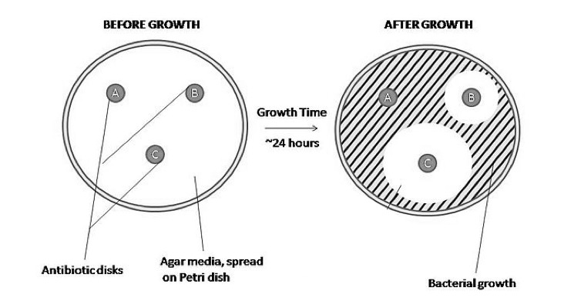
- The image below shows the results of an experiment on antibiotics.

Write a conclusion for this experiment. (4)

Any four from:
- The ring around the disk where no bacteria have grown is called the zone of exclusion.
- The zone of exclusion shows how effective the antibiotic is at killing bacteria.
- ‘A’ has no antibiotic properties as it does not kill any bacteria.
- ‘B’ has antibiotic properties as it kills some bacteria around the disk.
- The most effective is ‘C’ as it kills the most bacteria around the disk.

B: Human defence systems, vaccination and antibiotics
- The Andaman Islands of India are very remote and remain untouched by modern civilization.
A British expedition visited in order to carry out a survey of the islands. In a strategy to try and demonstrate friendliness, the expedition kidnapped an elderly couple and 4 children. The prisoners were taken to the mainland and given lots of food and gifts. After a couple of days, the prisoners were taken back to the Islands and released with gifts for the tribe.

The British expedition team was accused of starting a measles outbreak amongst the Andamese people. The outbreak killed the elderly couple and left many others very ill. Nobody on the expedition team was ill.

Explain how this could be possible.
(4)
2 marks for describing why the expedition team did not become ill and 2 marks for why the tribes people did become ill.

Expedition team may have been vaccinated against measles and so they were immune.
Expedition team may have suffered the disease themselves and developed immunity to measles.
Tribe people did not have any immunity to the measles virus
Expedition team may have been infected but did not show symptoms because their immune system made antibodies rapidly to destroy the measles pathogen before it had reproduced to sufficient quantities to cause symptoms to develop..
Tribe people had no antibodies against measles as they had never been infected by the pathogen before.
It would take several days before the tribe people’s immune system would begin to have an effect on the pathogens. They would become ill.
The elderly couple died because their immune system was not as effective as a younger person.
Elderly couple and children were taken off the Island and they may have come into contact with other people who were infected with measles.
It takes a few days for the symptoms to be apparent and the elderly couple and children were back on the Island by this time.
- The sketch graph shows the rate of antibodies production when a person becomes infected with the chicken pox virus. Annotate the graph below to describe what is occurring at each of the 4 stages of the immune response to the pathogen. (5)
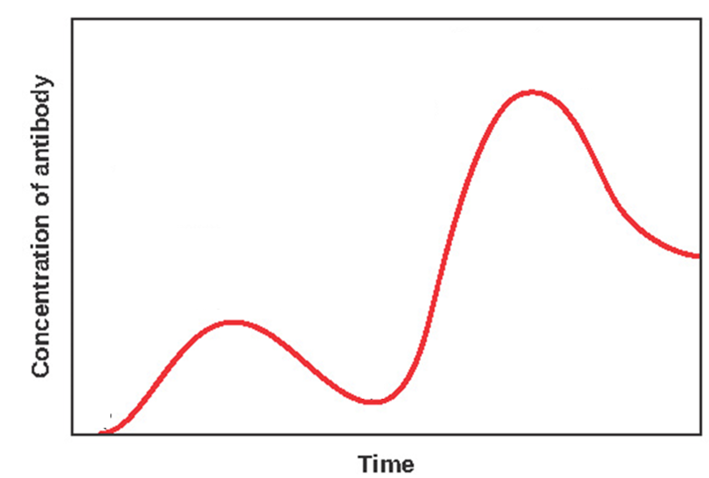
D
C
B
A
Two from:
A = Initial infection by pathogen
White blood cells start to manufacture specific antibodies but slowly
The pathogen is reproducing and causing the symptoms of the infection
One from:
B = Large amounts of antibody have been released and this is destroying the pathogens reducing their numbers
The infection is under control
White blood cells reduce the rate of antibody production
One from:
C = Secondary infection by pathogen occurs
White blood cells begin to produce antibodies rapidly to destroy the pathogen before it can reproduce in large numbers
One from:
D = Infection under control and the white blood cells reduce the rate of antibody production
Extended response question:
- A salmon farm uses large quantities of antibiotics to increase fish production. Large numbers of salmon of similar ages are kept together in tanks.
Describe the economic benefits and drawbacks of this approach. (6)
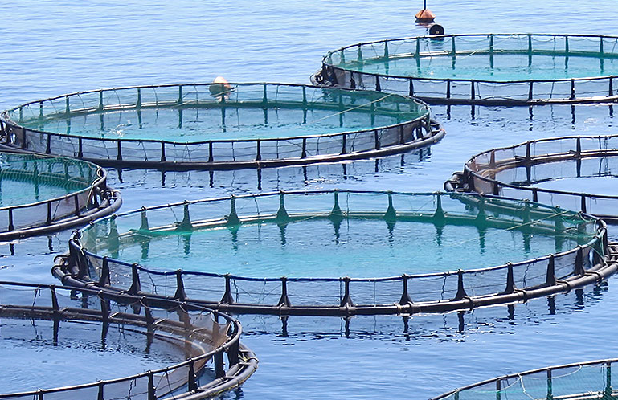
- Level 3 (5-6 marks)
Detailed analysis of at least three economic benefits AND at least three drawbacks are provided in a clear, logical and coherent reasoned answer.
- Level 2 (3-4 marks)
A partial answer with at least two of the economic benefits AND two drawbacks discussed with some reasoning.
- Level 1 (1-2 marks)
One or two benefits and/or one or two drawbacks are considered with little logical reasoning

Biological content:
Lots of fish in a small area means if one fish becomes infected with a bacterial disease, the disease spreads rapidly. (Drawback)
Keeping fish in densely populated tanks means it is easier to manage and more cost effective. (Benefit)
The dosage of antibiotics/food can be changed according to the age of the fish (Benefit)
People are unlikely to buy fish if they are diseased (Drawback)
The disease may reduce how well the fish grow (Drawback)
The farmer will receive less income for small/diseased fish (Drawback)
Antibiotics kill bacterial pathogens (Benefit)
The farmer will make more profit if he has healthy large fish to sell (Benefit)
The fish may not need antibiotics and so it is an unnecessary cost (Drawback)
The fish may contract a viral disease which will not be treated by costly antibiotics (Drawback)
By using lots of antibiotics the farmer may increase the chance of bacterial resistance developing. (Drawback)
It is not expected at this point that most students will link the overuse of antibiotics to development of bacterial resistance as this has not been taught in detail. There is a link to this in the specification so it is possible students may include this in their answer and this should be credited.

Biology Only question
- The measles vaccine is now combined with that for two other serious diseases - mumps and rubella. This is called the MMR vaccine. Measles can lead to serious complications such as pneumonia, blindness, miscarriage in pregnant women and inflammation of the brain (encephalitis).
The table below shows the risk of a complication occurring in children who have had the MMR vaccine and in unvaccinated children who get infected with measles.
Complication | Statistical risk associated with the MMR vaccine | Statistical risk associated with a measles infection
Diarrhoea | 0 | 1 in 6 people
Ear infection | 0 | 1 in 20 people
Pneumonia | 0 | 1 in 25 people
Fits (convulsions) | 1 in 1000 people | 1 in 200 people
Meningitis/encephalitis | 1 in 100 000 people | 1 in 1000 people
Severe allergic reaction | 1 in 24 000 people | 0
Death | 0 | 1 in 5000 people
Serious brain complications | 0 | 1 in 8000 people

Using the information from the table above and your own knowledge, describe the benefits to the individual, family and wider community of a parental decision to vaccinate their child and suggest why some parents may decide not to vaccinate their child. (5)
Three benefits (1 mark each) to individual and family and wider community discussed.
A reason (1 mark) given for why parents may choose not to vaccinate USING information from the table.
A reason (1 mark) given for not vaccinating which may or may not involve using data from the table.
Content:
 | Benefit of vaccination | Reason why a parent may decide not to vaccinate
Individual | Vaccine prevents measles for which there is no cure.  5 x less likely to have a fit than someone who becomes infected with measles.  Credit any other accurate use of data in table. | Risk of child having a fit is 1 in 1000 (or any other use of data from table)  Do not want child to have to go through having an injection.  Won’t suffer a severe allergic reaction to the vaccine.  Because most children are now vaccinated against measles it is rare. Parents may feel vaccination is unnecessary now because of this.
Family | Will not have to take time off work to care for child sick or dying from measles.  Will not see child suffer from measles.  Anyone with a weakened immune system is not compromised.
Wider community | Less chance of an epidemic  Child will not be a risk to others including pregnant women and those with weak immune systems.  Will not use costly resources to care for measles infected child e.g. hospital.  Will be able to mix with other children and not be in danger if a measles outbreak occurs.

- Discovery and development of drugs, monoclonal antibodies (HT Biology only)
- Why in the past might people have chewed on the bark of a willow tree if they had a headache? (2)
Aspirin is found naturally occurring here
It is a painkiller
- a) Drug trials are used to find out about dosage.
Why is this important both to the patient and economically? (2)
1 mark relating to the patient:
The dose is sufficient to treat the disease without being toxic
The dose does not give undesirable side effects
1 mark relating to economic importance:
To use the least amount of drug to get the maximum effect to save costs

- In the initial stages of a clinical trial a low dose of the drug is used on healthy volunteers.
Suggest why this is not used with patients at this point. (2)
Patients need to take their prescribed drug which has been proved to be effective for their condition - their condition may get worse if they are not taking this medication.
The new drug may have side effects that patients can’t cope with because they are unwell.
- Traditionally drugs were extracted from plants or micro-organisms. Most new drugs are now made in a laboratory, but the initial starting point may still have been a naturally occurring chemical in a plant.
Suggest why it is advantageous to use synthetic drugs rather than extracting it from a plant. (2)
Can produce the drug faster and in sterile conditions in laboratory.
Plant drug has to be purified first.
Lots of space is needed to grow enough plants to make it worthwhile.

- Some people have severe allergic reactions to monoclonal antibodies. Why might this occur? (2)
Monoclonal antibodies come from mouse tissue
Some humans may be allergic to mice

5. Extended response question: (Biology HT only)
Evaluate the personal benefit of using monoclonal antibodies for diagnostic testing. (6)
- Level 3 (5-6 marks)
A clear, logical and coherent answer which shows the student understands the benefits of monoclonal antibodies to individuals.
- Level 2 (3-4 marks)
A partial answer with some discussion of the benefits to an individual.
- Level 1 (1-2 marks)
One or two relevant points but concentrates more on how monoclonal antibodies are produced or work which is not relevant.
Biology Content:
Pregnancy test kits - easy to use, readily available and accurate indicator of pregnancy
No need to consult a GP
Can start to take care of health of fetus from day one
Use to identify certain chemicals in blood or urine quicker and less invasive than traditional methods, e.g. early indication of prostate cancer, illegal drug use in horses and athletes.
STD testing done without embarrassment of attending a clinic. Get early treatment if positive result and reduce spread of STD potentially.

D: Plant defence (Biology only)
- Suggest how the following plants have evolved to defend themselves against pathogens and herbivores. (6)

Leaves curl when touched.
Any insects on the leaves then fall off so less likely to be damaged and allow pathogens entry.
Movement makes the animals wary and so they move away.

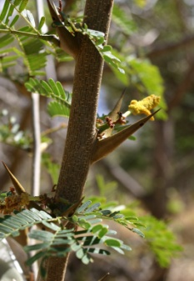
This acacia plant has hollow thorns which are colonised by ants.
Thorns are sharp and so deter the herbivores as they are painful to touch and eat.
Thorns are large in comparison to leaves so very obvious.
Ants live inside the thorns and if the thorns are disturbed the ants may attack. This puts off other insects/herbivores from eating the leaves and allowing pathogens entry into the plant.

Cody Hinchliff 2004 - English Wikipedia
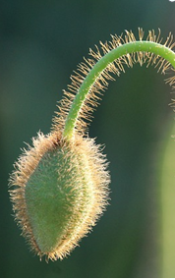
Hairy stems and leaves deter animals and insects as may contain a chemical - like nettles which sting or be like fine thorns e.g. in a cactus.
May make animals and insects think the plant is unhealthy and starting to rot.
Deters insects from laying eggs so young larvae won’t eat leaf etc.

